TOURISM & EVENTS NT ABORIGINAL TOURISM UPDATE - KEEPING YOU INFORMED || VIEW ONLINE



  NEWS
  PRODUCT SPOTLIGHT
  INDUSTRY OPPORTUNITIES
  EVENTS

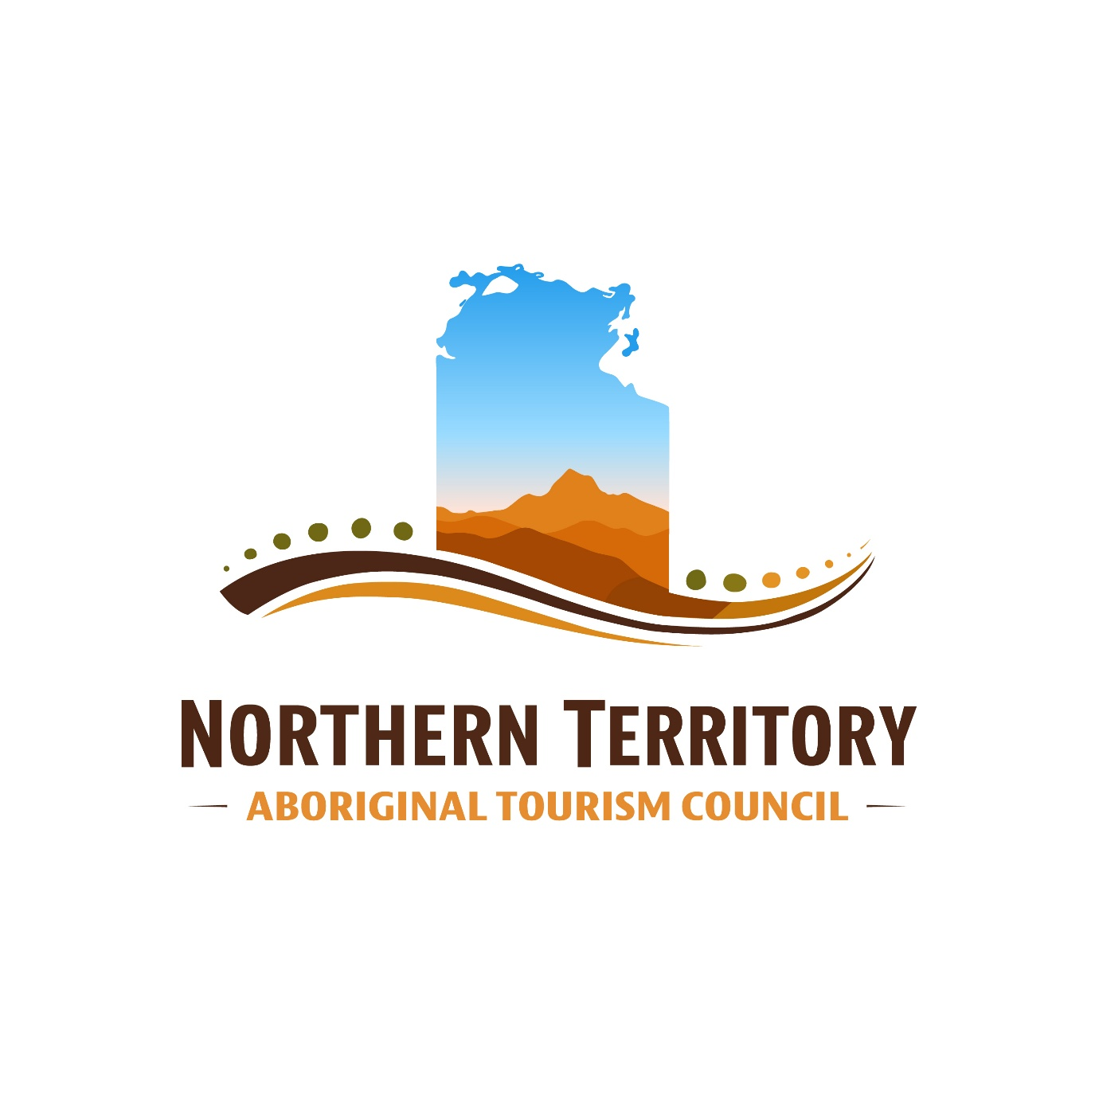

Northern Territory Aboriginal Tourism Council (NTATC)
The Northern Territory Aboriginal Tourism Council Ltd (NTATC) is the peak body representing Aboriginal tourism operators, businesses, guides, cultural experiences, and tourism enterprises throughout the Northern Territory (NT). NTATC supports Aboriginal-led tourism development through: advocacy, industry representation, marketing support, business mentoring, networking, training opportunities, government engagement, and strategic partnerships.
NTATC are building a stronger future for Aboriginal tourism across the NT through leadership collaboration and sustainable industry growth.

Read more

NEWS

  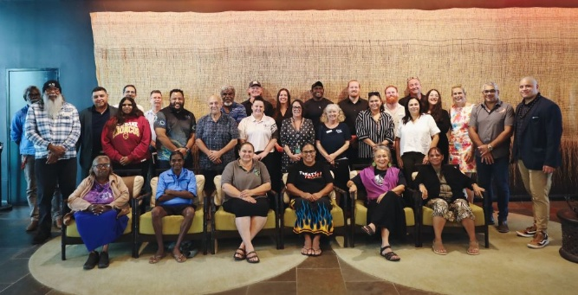
  NT Aboriginal Tourism Accelerator Program showcase
  Aboriginal culture is the heart of the Territory.
  As we celebrate 50 years of NAIDOC, we're proud to recognise the 2026 cohort of the NT Aboriginal Tourism Accelerator Program.
  Read more

  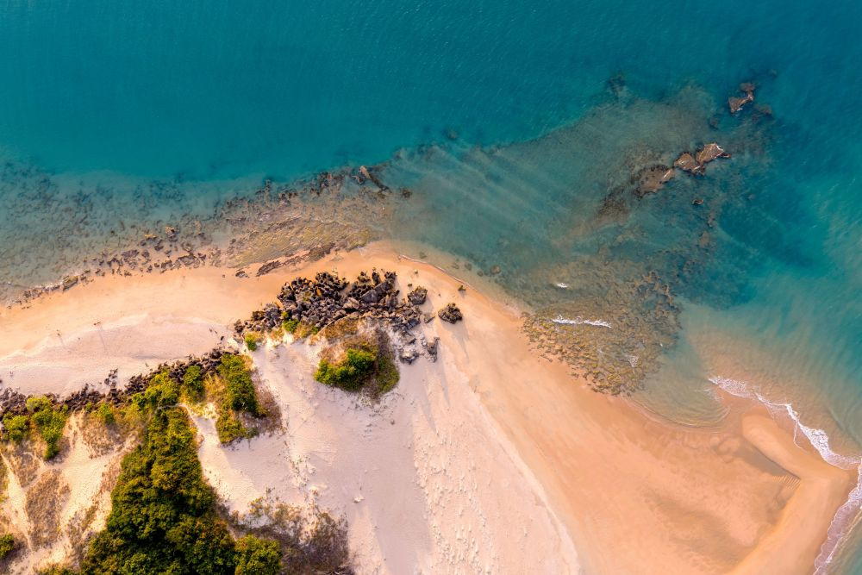
  Collective Impacts Initiative
  Aboriginal Investment NT's Collective Impact Initiative is providing grant funding and support to leverage collaboration and deliver large-scale, high-impact, community-led projects.
  Round two opens on 3 August 2026 and will remain open until 15 December 2026.
  Read more

  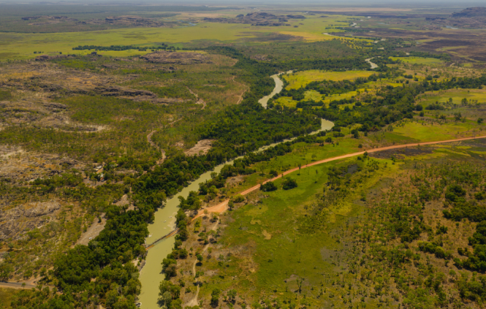
  Apply today - Community Benefit Fund Flood Relief Grant
  This grant aims to assist Territory based not-for-profit organisations that have been affected by the 2026 floods. The grant is a special round of one-off funding and eligible organisations can apply for up to $15,000 excluding GST.
  Read more

  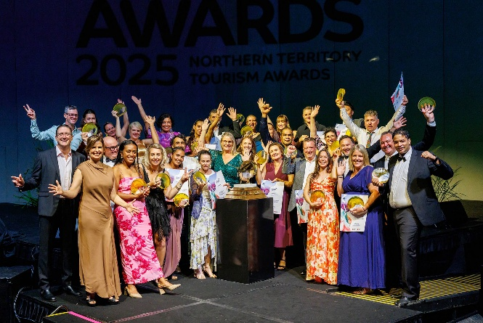
  Nominate today: Brolga Award
  The Brolga NT Tourism Awards (Awards) is the official tourism awards program for the NT. The Awards recognise tourism businesses that strive for excellence in every area of their operation. Majority owned Aboriginal tourism businesses are encouraged to nominate for the Aboriginal and Torres Strait Islander tourism experiences category.
  Read more

  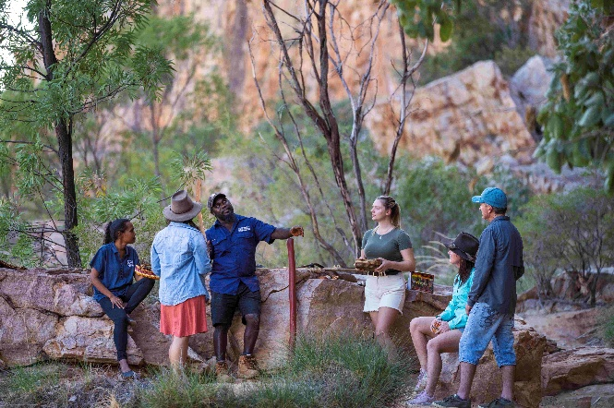
  Aboriginal tourism business secure NT Experience Fund
  Aboriginal tourism businesses are among the successful recipients of funding through the NT Government's first round of the NT Experience Fund.
  Funding will support the development of new visitor experiences, including a premium cultural dining experience at Nitmiluk National Park.
  Read more

PRODUCT SPOTLIGHT

  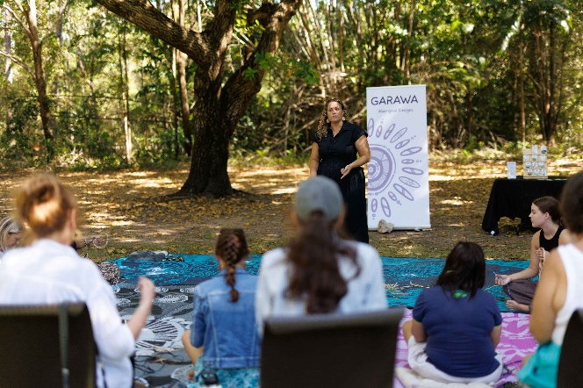
  Garawa Aboriginal Designs
  Step into a space of connection, story-telling, and cultural learning through a guided 1-hour cultural weaving experience at the Territory Wildlife Park. The workshop offers participants a respectful introduction to the art of weaving, focusing on the cultural significance, process and meaning behind the practice.
  Read more

  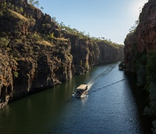
  Discover Aboriginal Experience: NitNit Dreaming 2 Gorge Tour
  This cruise will allow you to discover the cultural significance of two gorges to the Traditional Landowners the Jawoyn people. You will be enlightened by the history and traditions of the Indigenous inhabitants.
  Drinking water and toilet facilities are available on board the vessel. Please note there is a walk of approximately 400 meters each way. Special wheelchair access is available to the head of the first gorge only.
  Read more

INDUSTRY OPPORTUNITIES

  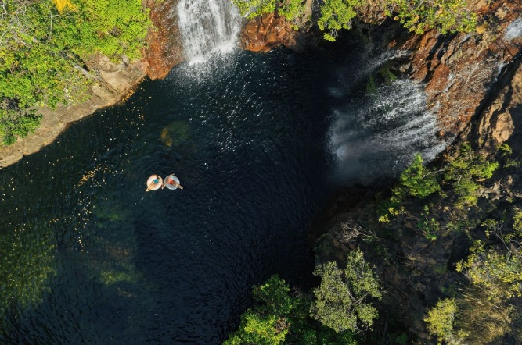
  Register today: Australian Tourism Data Warehouse (ATDW)
  ATDW is Australia's national tourism marketing platform. Having a business listing on ATDW is a requirement for your business to appear on the Tourism and Events NT consumer website. As an NT tourism operator, an ATDW listing is fully subsidised by Tourism and Events NT.
  Read more

  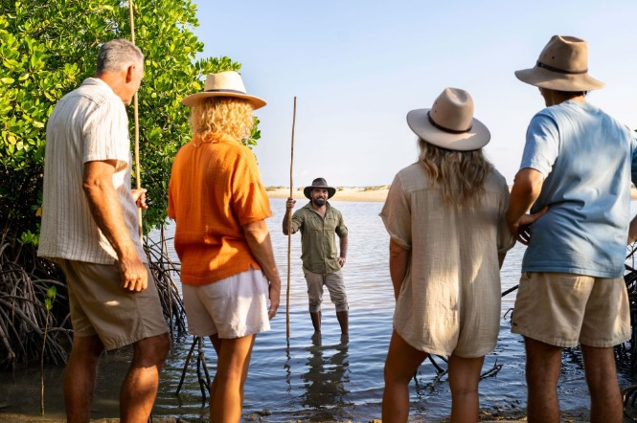
  Apply today - Australian Indigenous Tourism Conference
  Aboriginal tourism businesses are invited to apply for delegate funding to attend the Australian Indigenous Tourism Conference in Perth this November. The 3-day event will offer workshops, industry insights, and networking opportunities.
  Read more

  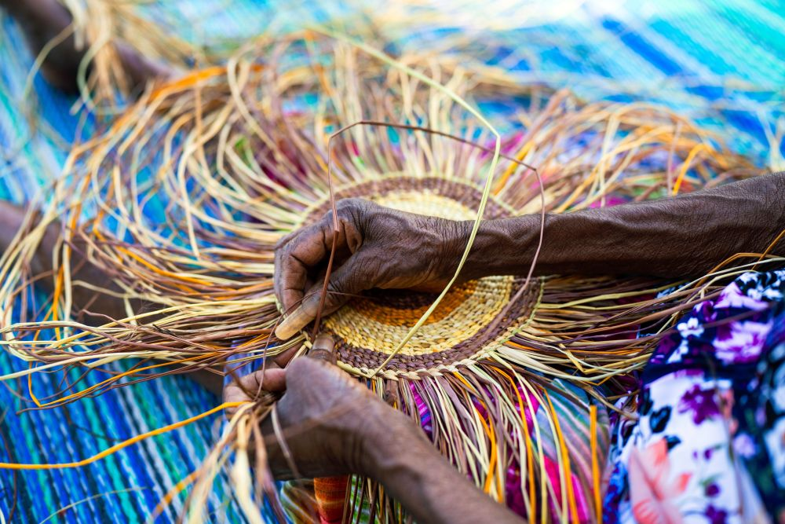
  Online business essentials workshops
  Indigenous Business Australia is hosting business essentials workshops for Aboriginal and Torres Strait Islander people who want to increase their knowledge of business fundamentals and take the next steps towards business ownership. The 2-3 hour workshops are free and delivered online.
  Read more

  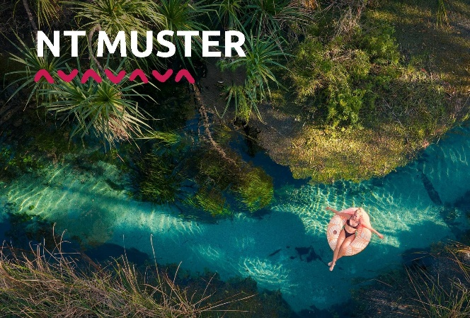
  NT Muster 2026 - Operator EOI registration
  Tourism and Events NT are excited to announce that NT operator registrations are now open for the annual NT Muster trade events. We're looking forward to another successful year, with three events taking place in Melbourne, Brisbane and Sydney. Please note there is a maximum of 20 operators able to participate, so please register your participation now.
  Read more

  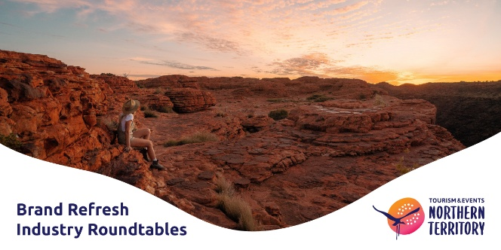
  Tourism and Events NT - Brand Refresh Industry Roundtables
  Tourism and Events NT is refreshing the Territory's destination brand - and we want to build it with you. Your insights will directly shape a brand built to drive visitation, support your business, and put the Territory on the global map like never before. Come and have your say.
  Read more

  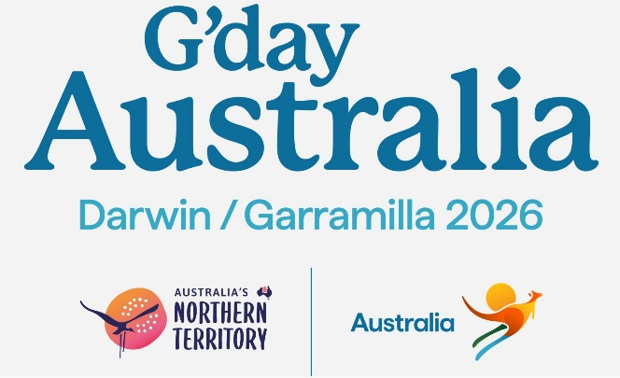
  G'Day Australia 2026
  Tourism and Events NT in partnership with Tourism Australia will host G'Day Australia in Darwin in 2026. G'day Australia is held every two years and brings Aussie Specialist travel agents from around the world to meet Australian tourism operators.
  Read more

  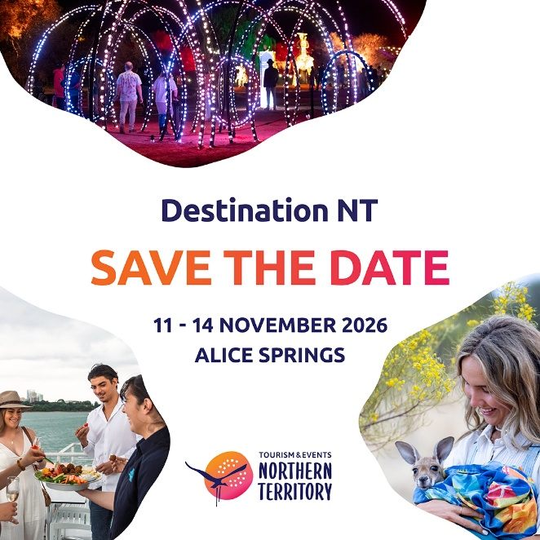
  Save the Date - Destination NT 2026
  - Wednesday 11 November - Sector-specific sessions
  - Thursday 12 November - Aboriginal Tourism Forum
  - Friday 13 November - Destination NT Conference
  - Saturday 14 November - Brolga Northern Territory Tourism Awards
  Read more

EVENTS

  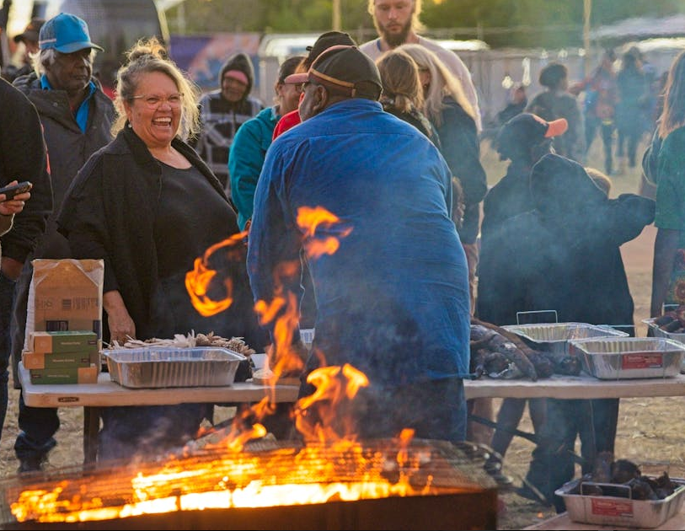
  Desert Harmony Festival
  A celebration of culture, community, and creativity in the heart of the Barkly from 31 July to 3 August. This year's theme, Yarntarnpa Kululu-jju Nyinta (Living together as One), acknowledges the diversity of the people in the Barkly region which continues to enrich the cultural fabric of the community.
  Read more

  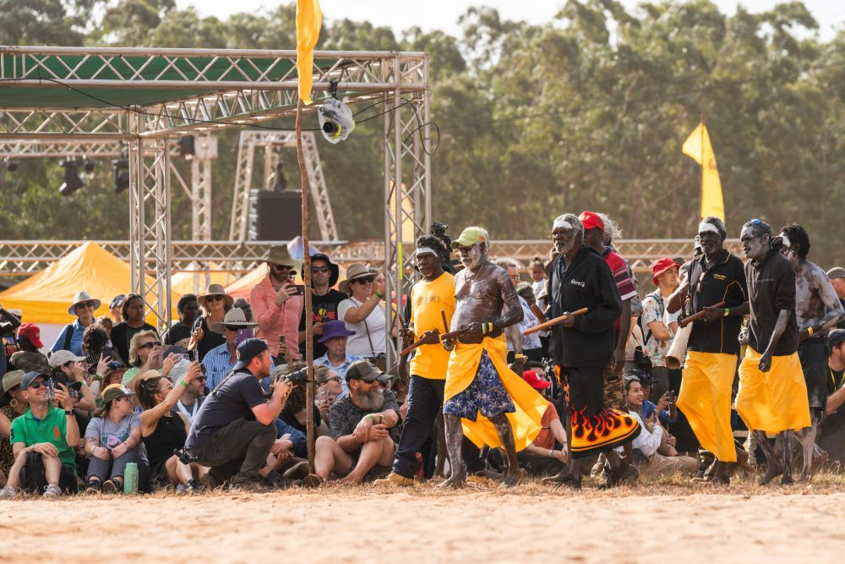
  Garma Festival
  Hosted by the Yothu Yindi Foundation, Garma is like nothing you have experienced before - a place where the freshwater and saltwater meet, and opportunity for cross-cultural exchange. Daily workshops give Garma guests the chance to immerse themselves in different aspects of Yolngu culture. The festival is from 31 July - 3 August 2026.
  Read more

  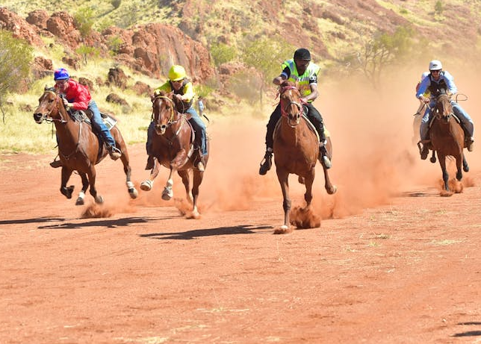
  Harts Range Races, Rodeo and Bush Sports Weekend
  Running from 31 July to 3 August at the Harts Range Racecourse in the East MacDonnell Rangers, the Harts Range Race is an iconic outback event that brings together communities for a unique weekend of racing, rodeo, family activities and bush entertainment.
  Read more

  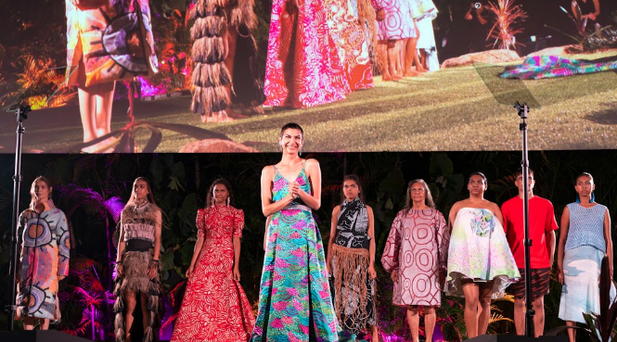
  National Indigenous Fashion Awards
  On Wednesday 5 August, the National Indigenous Fashion Awards takes place on Larrakia Country in Darwin. The event celebrates First Nations fashion through seven award categories, highlighting innovation, diversity, and cultural excellence.
  Read more

  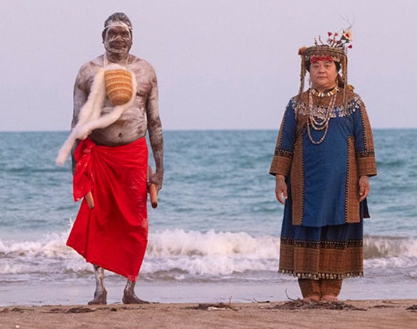
  Gapu Ŋupan (Chasing the Rainbow) - Darwin Festival
  Gapu Ŋupan brings together Yolŋu songlines from Northeast Arnhem Land with Paiwan and Amis storytelling from Taiwan in a powerful cross-cultural performance celebrating connection, culture, and collaboration. Created over five years and featuring renowned artists, the production returns to the NT for performances on 5-6 August.
  Read more

  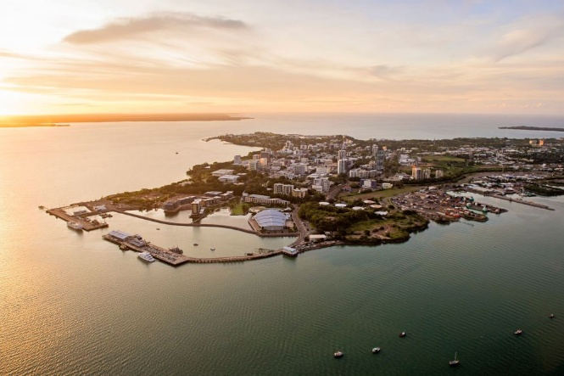
  Darwin Aboriginal Art Fair
  Experience the 20th Darwin Aboriginal Art Fair at the Darwin Convention Centre on Larrakia Country from 6 - 9 August, showcasing Aboriginal and Torres Strait Islander art, culture, and design, along with dance performances, workshops, artist talks, and family-friendly activities.
  Read more

  
  The Great First Nations Songbook
  Join Adam James and his band The Dreamtime Swing for The Great First Nations Songbook: A night of Swing and Soul, a vibrant celebration of iconic First Nations music reimagined with 1960s big band flair on Sunday 9 August. Presented by AANT Centre as part of the Darwin Festival, this captivating performance showcases beloved hits from artists including Jimmy Little, Yothu Yindi, Archie Roach and more.
  Read more

  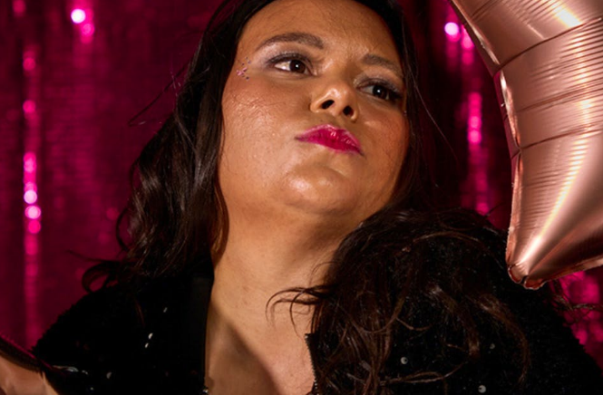
  Mema Munro: Wanna Be a Star
  Wanna Be a Star is a sharp, self-aware comedy show blending stand-up and theatre. It explores ambition, rejection, and the pursuit of stardom through humorous and honest reflection on her acting journey - performed at the Darwin Festival on 12 - 13 August.
  Read more

  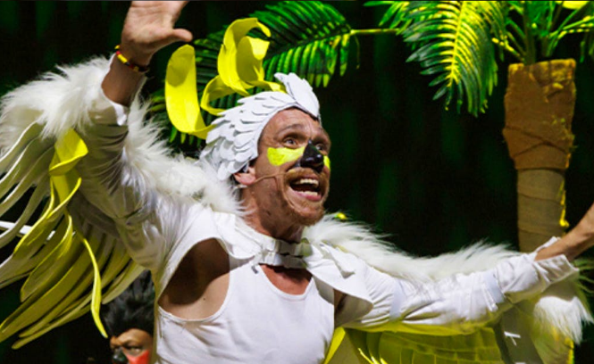
  Birmba - Darwin Festival
  On Saturday 15 August, Birmba brings children and families into an interactive rainforest theatre experience grounded in Kuku Yalanji language and culture. Through storytelling, music, and movement, audiences join three-cockatoos on a journey of connection, courage and care for Country.
  Read more

  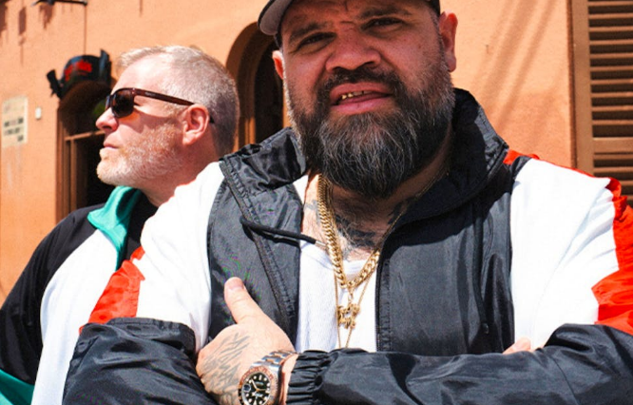
  Big Noter - Darwin Festival
  Briggs returns to the Top End on Friday 21 August with his new project Big Noter, shifting from hip-hop to a raw, guitar-driven live band. The show highlights his powerful stage presence and marks a return to his musical roots, drawing on over 15 years of touring experience across Australia and Europe.
  Read more

  LOGIN TO ATDW
  VIEW VISITOR DATA
  JOB OPPORTUNITIES
  TOURISM & EVENTS NT WEB

  This email has been sent by Tourism & Events NT. You have received this email because you have subscribed to a Tourism NT mailing list.
  Department of Tourism and Hospitality
  GPO Box 1155, Darwin NT 0801
  
   |  |  |  | 

To change your Subscription Preferences to Tourism NT communications click here
Click here to unsubscribe from all communications from Tourism NT.

